1. a. 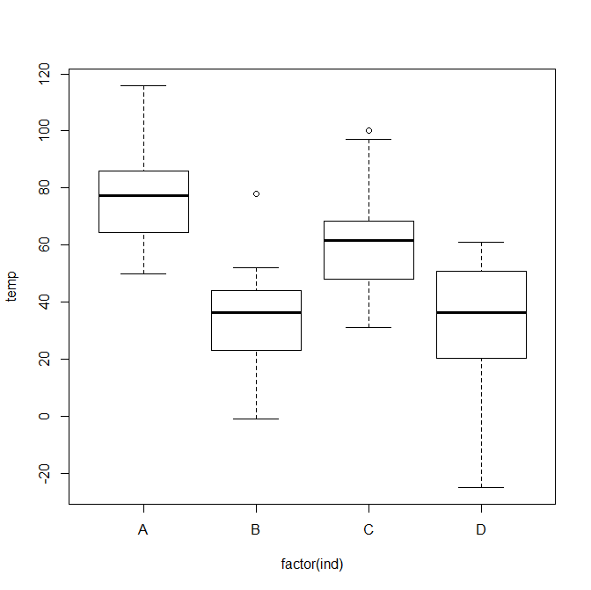

b. Yes, there seem to be outliers. Here’s a nice table with all of the data

|  |  |  |  |  |
| --- | --- | --- | --- | --- |
|  | A | B | C | D |
| Median Temperature | 77.5 | 36.5 | 61.5 | 36.5 |
| Largest Outlier | 116 | 78 | 100 |  |
| Smallest Outlier | 50 | -1 | 31 | -25 |

c. Section A looks to be the warmest with a median of 77.5. I think it is the clear, it’s center mass sits above the rest, about 15 degrees above section C. It looks like A is about twice as warm as Sections B and D, going off the Median.

d. If forced to choose, I’d pick Section D. It is not very clear. Both B and D have the same Medians, The difference being that D’s lowest outlier puts it ahead of B for me.

2. a. Here’s what came out:

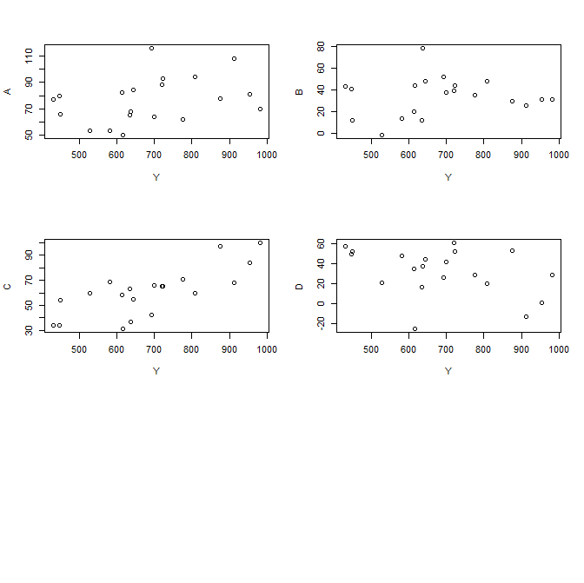

I choose the bottom left(C) for the tightest pattern.

b. Done, I think the line of best fit will be very close to the mean temperature of C.

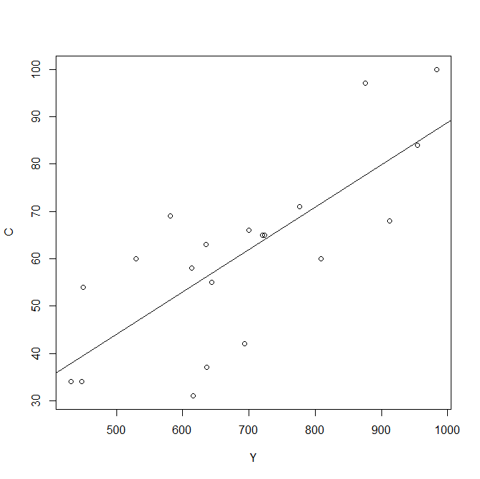

c. Here’s the graph, and it looks like I was right it part b:

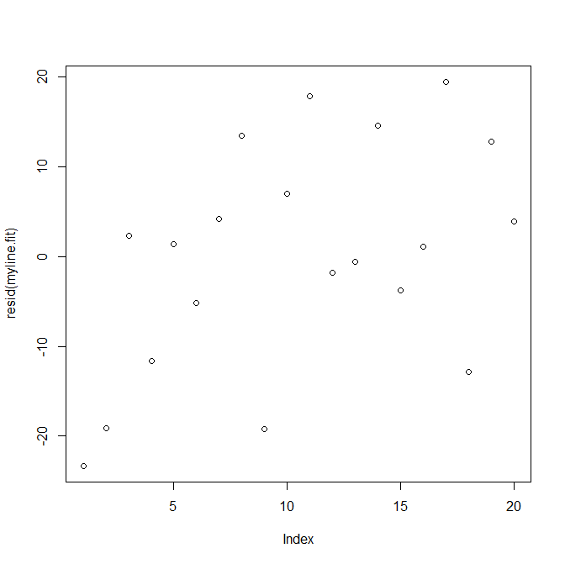d. And here’s that graph. I’m not exactly sure what I should be commenting on, but it looks quite all over the place. If force, I’d say the line of best fit has about a 45 degree slope, but the Standard Deviation is too much for me to have any confidence in that line.